Node Split across CMTS – Broadband and Voice service

Version Control:

Use Case Name: |  | Node Split across CMTS – Broadband and Voice service
Use Case Owner: |  | Sumit Borade
Current Version |  | 0.1
Use Case Version History
Modified Date | Version |  | Modified By | Change Description
Oct 02,2009 | 0.1 |  | Sumit Borade | Initial Version

Brief Description:
This use case describes the process by which YouSee outside plant engineering identifies that a node split needs to occur. A node split is a change to the HFC fiber plant which can result in subscriber’s being served by different network equipment. In the event that a node split results in subscribers residing on a different CMTS, then this use case will need to be invoked.

YouSee subscriber Node Split process will include steps to produce a list of device MAC addresses (cable modems) that will move from one CMTS to another CMTS during the node split. This list will be sent into the SMP system so the telephony and static IP address services may be re-activated.

The Modems can be online or offline from the New GI address. If the Modem is offline SMP will not be able to do a Reset on Cable Modem and is accepted by YouSee as a limitation

The use case is written from the perspective of the SMP provisioning solution.

Related Documents
- YouSee SMP SOW2Architecture Requirements Document
- YouSee SMP SOW2 Business Requirements Document
- Voice over Cable Use Case Activation
- Cisco BACC TC Specification
- P-Cube IP Traffic Management TC Specifications
- Static IP Notification TC Specifications

Related Use Cases

Pre-Conditions
- Subscriber is an active broadband and voice over cable subscriber.

Post-Conditions
- Subscriber is able to use the broadband and voice service from the new network locations.

Use Case

Primary Flow Diagram
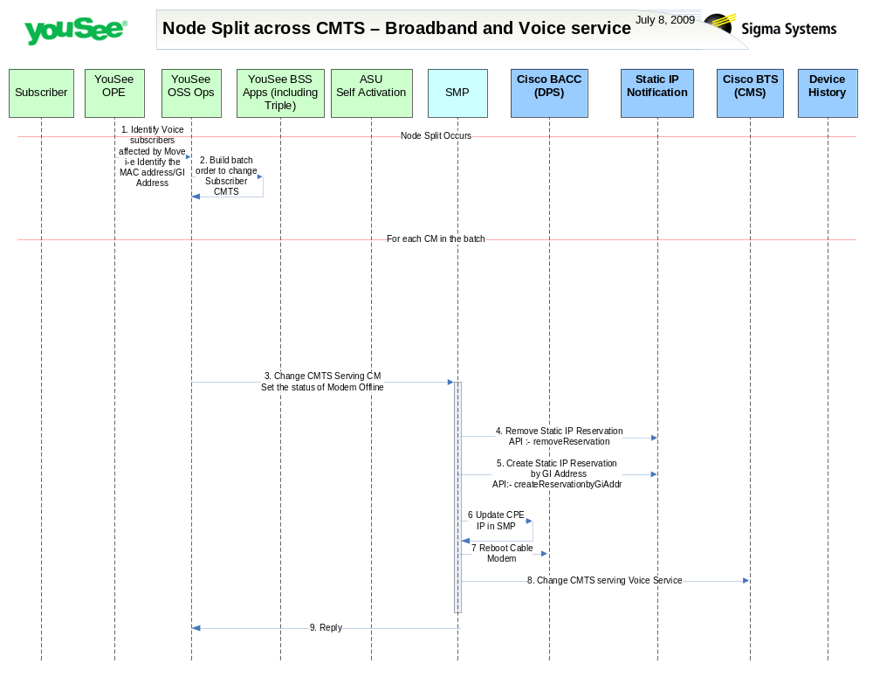

Primary Flow Detail
# | Actor: Key Action | Description | Alternate Flows/Details
Note: The first few steps in the use case occur when YouSee Outside Plant Engineering organization plan and implement a Node Split.
 | OPE: identify the set of voice subscribers affected by Node Split | Outside Plant Engineering is responsible for identifying the subscribers affected by a node split (or congestion relief) activity. OPE provides a list of CM MAC Addresses affected by the change.
 | OSS Ops: Builds batch order | OSS team needs to take the list of MACs from OPE and plan the activity
Note: The following steps in the use case occur for each subscriber/CM affected by the split
 | OSS Ops: requests activation | For each CM, OSS Ops will submit an order to SMP updating the CMTS serving the subscriber’s CM
 | SMP: request to YouSee static IP Notification system to re provision Static IP. | This step is optional and will be performed only if the subscriber has static IP Service in SMP. For Static IP to work SMP needs to re provision the Static IP with new IP Address.  This will remove the Static IP association for the CPE MAC address.  API Call to be used:-  removeReservation
 | SMP: request to YouSee static IP Notification system | This step is optional and will only be performed if the subscriber has static IP Service in SMP. SMP needs to inform Internal YouSee system that the IP to be assigned for this particular CPE MAC address is static.  API Call to be used:- createReservationbyGiAddr  API createReservationbyGiAddr will return the CPE IP Address to be made Static.
 | SMP: update SMP Database with Static IP Address | This step is optional and will only be performed if the Subscriber has a Static IP address on broadband plan. SMP will record the Static IP returned from the YouSee Static IP notification into its Database.
 | SMP: reboots the Cable Modem | SMP will reboot the Cable Modem so that Cable Modem gets the Reserved IP address
 | SMP: defines new CMTS in BTS | Sigma will update the configuration of the Voice service in BTS, defining the new CMTS serving the subscriber

